**38tH annual**

**REGISTRATION ASSISTANCE MARCH 7, 2025 FROM 10am-12pm AT FORT BENJAMIN PARK Use QR code for direct link to online registration**

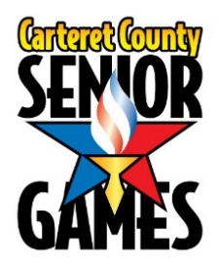

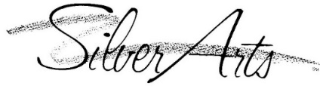**AND**

**Official Entry Form**

**Event Dates March 24-26(Pickleball), 2025**

**Regular schedule March 31 – April 23, 2025**

**Early Bird Registration Dates Online: January 13-February 28 Fee**= $15

**Final Registration Date: March 1-7 Fee**= $20

**\*\* Coordinating Agencies and Local Sponsors\*\***

**County of Carteret**

**Carteret County Parks & Recreation**

**Carteret County Health Department**

**Carteret Health Care**

**Morehead City Recreation Center**

**Star Hill Golf Club**

**Cape Carteret Aquatic & Wellness Center**

**Leon Mann Jr. Enrichment Center**

**Local Government Federal Credit Union/Civic**

**MacDaddy’s Bowling Center**

**West Carteret High School**

**Crystal Coast Civic Center**

**East Carolina Area Agency on Aging**

**Bobby Watson’s Carteret County Speedway**

**Friendly Market**

**Morehead Beaufort Elks Lodge 1710**

**Pro Environmental**

**Atlantic Beach Town Park**

***Carteret County Senior Games Mission Statement***

***“To promote healthy living and active lifestyles with community participation by setting and achieving goals in sports and arts competitions.”***

Carteret County Senior Games Official Entry Form General Information

**ELIGIBILITY A participant must be a North Carolina resident for a minimum of three (3) consecutive months of the calendar year.** A person must be 50 years of age or better to participate. “**A participants age on December 31,2025 determines the age categoryin which they will compete”.**

Participants will compete against others of their own age and sex as follows: 50-54, 55-59, 60-64, 65-69, 70-74, 75-79, 80-84, 85-89, 90-94, 95-99, and 100+. In doubles sports, the age of the youngest player determines the age group for competition.

**RULES** **Carteret County Senior Games are open games**. Any schedule changes must be made by March 20, 2025. **If you are entering doubles/mixed doubles, your entry in that event will not be complete until your partners form has be received. No partners will be assigned at events.**

All events will be conducted in accordance with the 2025 Edition of the North Carolina Senior Games Inc. Official Rules and SilverArts Booklet both of which are located on the website at **www.ncseniorgames.org**

**WHAT DO I RECEIVE?** Registration fee includes a participant t-shirt, participation in Athletic and/or Artistic Events and free admission to the following Events: SilverArts Exhibit and SA reception at Fort Benjamin Park. Opening Ceremonies, and Awards/Lunch held at Crystal Coast Civic Center.

**AWARDS** All medals will be awarded April 30, 2025. One gold, silver or bronze will be awarded to represent all events placed in, along with a documented list of all events placed in.

**WHAT IF IT RAINS?** Unless weather has made conditions hazardous to the safety of volunteers and participants, events will continue in the rain. Participants should report to the event site and check-in, regardless of the weather. Up to date information will be available from the Event Manager in charge of each event. As an added source of updates, like our Senior Games page on Facebook.

Failure to check-in will result in disqualification.

**STATE FINALS** All events offered at the local level will also be offered at the State Finals (except for those noted with an asterisk*). Participants receiving medal(s) (see above) will receive a State Finals Entry Packet **upon request** with a qualifying letter after the completion of the local Games.

Return entry to North Carolina Senior Games by August 1st.

Early Bird Registration deadline is July 1st.

This Program is sanctioned by North Carolina Senior Games, Inc. North Carolina Senior Games is sponsored State wide by the North Carolina Division of Aging and Adult Services.

**NATIONAL GAMES** 2025 is not a qualifying year for National Games, [www.nsga.com](http://www.nsga.com).

**CYCLING** 2025 cycling event will be held at Carteret County Speedway this year. You may call Carteret County Speedway to schedule a practice date.

**REFUNDS** No refunds will be granted after March 14, 2025. A $5 processing fee is non-refundable.

**GOLF** To qualify for State Finals, golfers need to meet a minimum performance score (MPS) **and** finish in the top 3 in their age group. Additionally golfers will follow a triple bogie, pick up and go, locally. MPS is available from your coordinator and in the NCSG Rules Book at [**www.ncseniorgames.org**](http://www.ncseniorgames.org)

**NEW EVENTS-Sports/Cornhole Mixed Doubles, Silverarts/Metal Working, Adult Coloring and General Crafts**

Carteret County Senior Games Official Entry Form Participant Information

**FIRST NAME___________________________ MI_______________________ Last Name________________________**

**MAILING ADDRESS_________________________________________________________________________________**

**CITY____________________________________STATE____________ZIP CODE________________________________**

**TELEPHONE #________________________ DATE OF BIRTH ____/____/_____ Age as of 12/31/2025 ____**

**EMAIL ADDRESS _______________________________________________________T-SHIRT Yes__ or No__ Size___**

**please provide the above information to help us better serve you. email is our main source of contact, please provide. it will be kept confidential. thank you!**

My ethnicity: Black or African American;___ Asian;___ American Indian or Alaska Native;___ Hispanic;___ White;___ Native Hawaiian or other Pacific Islander;___ Or Unknown /Refused___.  **Medical Information**

1. Name of physician: ______________________________ Phone#: __________________________ 2. Name of medications: _____________________________________________________________ __________________________________________________________________________________ 3. Your medical conditions: ___________________________________________________________ 4. Your allergies: ____________________________________________________________________

**Emergency Contact Information**  Name: _________________________________________ Phone #: _________________________ Relationship: _______________________________________________________________________ Name: _________________________________________ Phone #: _________________________ Relationship: _______________________________________________________________________ **FEES Early Bird registration fee – received in office by Friday February 28, 2024…..……….$15.00_________ Final deadline registration fee – received March 7, 2025……..………………………………. $20.00_________ Golf – includes cart, green fees and lunch………………………………………………………………$40.00_________ Bowling – 3 games WITHOUT SHOES…………………..…………………. # of Events _____x $10.00_________ Opening Ceremonies March 27, 2025..…………………………………………………………………..YES____NO_____ Silverarts Reception/April 17, 2025 ………………………………………………………………………YES____NO_____ Lunch/Awards Finale/April 23, 2025 ……………………………………………………………………..****YES____NO_____ Luncheon Guest……………………………………………………………………………………………………..$10.00_________ Mini Golf………………………………………………………………………………………………………………..$7.00__________ Make checks payable to: Carteret County Senior Games Total Amount Enclosed=_________**

**Mail Entry forms with check/money order to: *Carteret County Senior Games 100 McQueen Avenue Newport, NC 28570* Checks should be made out to Carteret County Senior Games (CCSG) *R*egistration assistance available at Fort Benjamin Park, 252-222-5858 or 252-515-3290 Online registration available at http://torch.ncseniorgames.org**

**___**

Participant Information

Carteret County Senior Games Official Entry Form Athletic Events

First Name__________________________________ Last Name___________________________________ MI_____

check box to the left of your event choice

***To promote total health and physical fitness, events of longer duration and lower intensity are strongly***

***recommended. High-intensity types of activities are offered primarily for the conditioned, trained athlete.***

**Individual Sports Tournament Sports* Swimming*(Limit 6)**

|  |  |
| --- | --- |
|  | **Bowling\*** |
|  | Singles |
|  | Doubles  Name Partner: |
|  | Mixed Doubles  Name Partner: |
|  | **Cycling\*** |
|  | 1 Mile |
|  | 5 K |
|  | 10 K |
|  |  |
|  | Football Throw* |
|  | Softball Throw* |
|  | Golf*/Handicap: |
|  | Mini Golf * |
|  |  |
|  | **Track & Field (Limit 5)\*** |
|  | 50 M Dash |
|  | 100 M Dash |
|  | 200 M Dash |
|  | 400 M Dash |
|  | 800 M Dash |
|  | 1500 M Dash |
|  |  |
|  | Running Long Jump |
|  | Standing Long Jump |
|  | Shot Put |
|  | Discus |
|  |  |
|  | Silverstriders Fun Walk |

**offered at State Finals.**

**Silver Arts   
(Literary ENTRIES must be returned with registration info)**

|  |  |
| --- | --- |
|  | **Pickleball\*** |
|  | Doubles  Name Partner: |
|  | Mixed Doubles  Name Partner: |
|  |  |
|  | Billiards* |
|  | Bocce* |
|  | Croquet* |
|  | Horseshoes* |
|  | Shuffleboard* |
|  | **Table Tennis\*** |
|  | Singles |
|  | Doubles  Name Partner: |
|  | Mixed Doubles  Name Partner: |
|  | **Tennis\*** |
|  | Singles |
|  | Doubles  Name Partner: |
|  | Mixed Doubles  Name Partner: |
|  | Basketball Shoot* |
|  | Cornhole* |
|  | Cornhole Mixed Doubles*  Name Partner: |

|  |  |
| --- | --- |
|  | **Backstroke** |
|  | 50 Yards |
|  | 100 Yards |
|  | 200 Yards |
|  | **Breaststroke** |
|  | 50 Yards |
|  | 100 Yards |
|  | 200 Yards |
|  | **Butterfly** |
|  | 50 Yards |
|  | 100 Yards |
|  | 200 Yards |
|  | **Freestyle** |
|  | 50 Yards |
|  | 100 Yards |
|  | 200 Yards |
|  | 500 Yards |
|  | **Individual Medley** |
|  | 100 Yards |
|  | 200 Yards |
|  | 400 Yards |

**Please refer to *Schedule of Events* for dates, times and event sites.**

* **Doubles Partners – If individuals partner cannot come to State Finals, that person may select another partner who qualified in that event** **at the Local Games.**
* **Age of younger partner will determine age group**
* **Partners must be registered by March 14, 2025. No partners will be assigned at events**
* **Bowling, Mini Golf and Golf Events require an extra fee**

**LIMIT OF 3 ENTRIES PER SUBCATEGORY**

**Entries must be the original work of the artist and must have been completed within**

**2 years of the Local Games qualifying date.**

**HERITAGE ARTS** **VISUAL ARTS:**

____ Acrylics

______ Basket Weaving Adult Coloring **(New for 2025 local only)**

______ Stained Glass _______Digital Art

____ Crocheting Mixed Media ___2D or ___3D

____ Pottery(Thrown and Hand built) Oil  
____ Jewelry Pastels

____ Knitting Photography (Film)

____ Needle Work Photography (Digital)

____ Quilting (Machine Stitched) Sculpture

______ Quilting (Hand stitched) ______Watercolor

____ Weaving **LITERARY: Entries must be submitted with your entry form**

____ Tole/Decorative Essay (8 pages max, double space, non biographical)

____ Wood Working Life Experience (auto biography, 8 pgs. max, double space)

Wood Carving Poem (40 lines max)

Wood Turning Short Story (8 pgs. max, double space)

______ General Fiber Arts

______ Metal Working **(local only)**

______ **GENERAL CRAFTS** **(New for 2025 local only)**

***LIST TITLE OF ENTRY ON LINES BELOW!***

**Please list names of all items submitted for Heritage, Visual and Literary Arts Categories:**

**1**

**2**

**3**

**4**

**PERFORMING ARTS:**

Act Name____________________________Group/Solo_____________________Number in Act_______

Music Information(Song Title)___________________Equipment Needed___________________________

Length of Act____ Act Type: Comedy/Drama___ Line Dance___ Vocal___ Instrumental___ Dance___

**CHEERLEADERS:**

Group Name _______________________________ Head Cheerleader______________________

Group Size_______ Music Title (If used) ______________________________

Act Length (Min/Sec) ________ Introductory Statement _________________________________________________________________________________

**SIGNATURE FORM**

**Liability Waiver/REQUIRED**

I acknowledge and fully understand that I will be engaging in activities that involve risk of serious injury, including permanent disability and death, and severe social and economic losses which might result not only from their own actions, inactions or negligence, but the actions, inactions or negligence of others, the rules of play or the condition of the premises or of any equipment used. I assume all the foregoing risks, and accept personal responsibility for the damage following such injury, permanent disability or death. I release, waive, discharge and covenant not to sue the Carteret County Senior Games, its affiliated clubs, their respective administrators, directors, agents, sponsoring agencies, sponsors, advertisers and if applicable, owners and leasers of premises used to conduct the events, all of which are hereinafter referred to as “releases” from any and all liability to each of the undersigned, his or her heirs and next of kin for any and all claims, demands, losses or damages on account of injury, including death or damage to property, caused or alleged to be caused in whole or in part by the negligence of the release or otherwise. I have prepared myself for the events which I have entered by practicing prior to the Carteret County Senior Games. To the best of my knowledge and belief, I have no physical restrictions that would prohibit my participation in the events I have selected.

Carteret County Senior Games has my permission to transport me and to have a physician attend me if it is deemed necessary during my participation in local games. I agree to release and hold harmless the Carteret County Senior Games from any damage to or loss of my art entry. I certify that the art piece(s) I enter are my own work, were created after having reached age 50, and are not manufactured in any sense of the word. I grant to the Carteret County Senior Games the free and unrestricted right to use my name and picture, picture of my art work and/or written material in any broadcast, telecast or other written or photographic account to the Carteret County Senior Games without remuneration.

* **I understand it is my responsibility to read and be accountable for the information in this Official Entry Form Packet and that all information and resources for finding information pertaining to Carteret County Senior Games has been offered to me.**
* **I understand that I am to participate by the rules of Carteret County Senior Games and know that all information can be found on the Rule Changes and Reminders Page of the Official Entry Form Packet.**
* **“I understand that it is my responsibility to check with my local Senior Games Coordinator immediately following my local Senior Games to determine if I qualified for State Finals and to get a State Finals Entry Packet if I do not have internet access. My State Finals registration with payment and all required items must be received in the NCSG office in Raleigh by 11:59 p.m. on August 1st! I understand that this deadline is strictly enforced in fairness to all and it is my responsibility to make sure I am registered.”**

I have read the above information I have read the above information

_______________________________ ______________________________ __________

Print Name Signature Date

ADDITIONAL INFORMATION CAN BE FOUND ON NCSG WEBSITE @ http://www.ncseniorgames.org/

**See SilverArts Guidelines for general requirements**

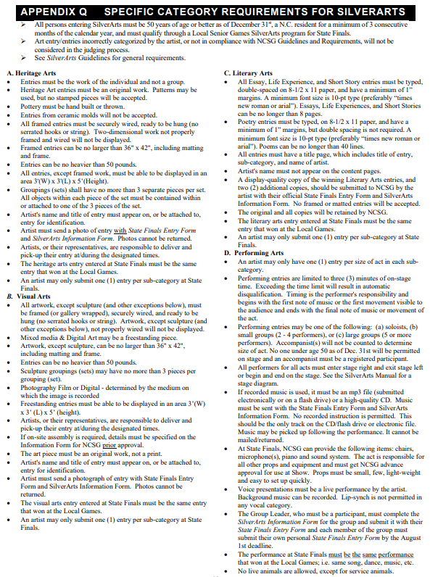

**See SilverArts Guidelines for general requirements**

|  |  |  |  |
| --- | --- | --- | --- |
| **Date** | **Time** | **Event** | **Location** |
| Monday March 24  Tuesday March 25  Wednesday March 26 | 10am | Pickleball Doubles  Pickleball Mixed Doubles | CIVIC |
| Thursday March 27 | 9am-11am | Opening Ceremonies | Leon Mann |
| Friday March 28 | 9am | Horseshoes | FBP |
| Monday March 31 | 8am | Silverstriders Fun Walk | FBP |
| Monday March 31 | 9am-11am | Silverarts Drop off | FBP |
| Monday March 31 | 10am | Bocce | FBP |
| Tuesday April 1 | 9am | Football Throw | FBP |
| Tuesday April 1 | 10am | Softball Throw | FBP |
| Tuesday April 1 | 11:30am | Croquet | FBP |
| Wednesday April 2 | 9am | Billiards | FBP |
| Wednesday April 2 | 9am | Shuffleboard | FBP |
| Thursday April 3 | 5-7pm? | Tennis | FBP |
| Friday April 4 | 9am | Table Tennis | FBP |
| Monday April 7 | 9am | Cornhole | CIVIC |
| Tuesday April 8 | 9am | Cycling | CCS |
| Tuesday April 8 | 2pm | Swimming | CCAW |
| Wednesday April 9 | 9am | Basketball Shoot | MHCRC |
| Thursday April 10 | 10am | Bowling | MAC |
| Friday April 11 | 9am | Track & Field | WCHS |
| Monday April 14 |  | Rain Date |  |
| Tuesday April 15 | 9am | Golf | SHGC |
| Wednesday April 16 | 9am | Mini Golf | ABTP |
| Thursday April 17 | 5-6:30 pm | Silverarts Reception and Art Pickup | FBP |
| Friday April 18 |  | HOLIDAY |  |
| Wednesday April 23 | 11am-1pm | Finale/lunch/medal presentations | CIVIC |

ABTP=Atlantic Beach Town Park Leon Mann=Leon Mann Center

CCAW=Cape Carteret Aquatic & Wellness MAC=MacDaddy’s Bowling Center

CCS=Carteret County Speedway MHCRC=Morehead City Recreation Center

CIVIC=Crystal Coast Civic Center SHGC=Star Hill Golf Club

FBP=Fort Benjamin Park WCHS=West Carteret High School

***“This program is sanctioned by North Carolina Senior Games, Inc. NCSG, Inc. is sponsored statewide by the North Carolina Division of Aging and Adult Services.”***

***“ALL EVENT TIMES AND DATES SUBJECT TO CHANGE IF NESSESARY DUE TO***

***INCLEMENT WEATHER CONDITIONS”***

Carteret County Senior Games 2025 Schedule of Events